**I. The z-score**

__________________________________________ (mean, median, mode) give us a number

in which a data set is centered. ___________________________________ (range, standard

deviation) tells us how much the data set is spread out from that centered point.

This section is about ____________________________________ which looks at individual

items within a data set and those measures are ____________________________________.

Chebyshev’s theorem states that 89% of items in any set, lie within 3 standard deviations of the mean. In other words, 89% of the items will have a _______________ between -3 and +3. Actually 99% of items are within 3 standard deviations so a z-score less than -3 or greater

than +3 is a rare occurrence.

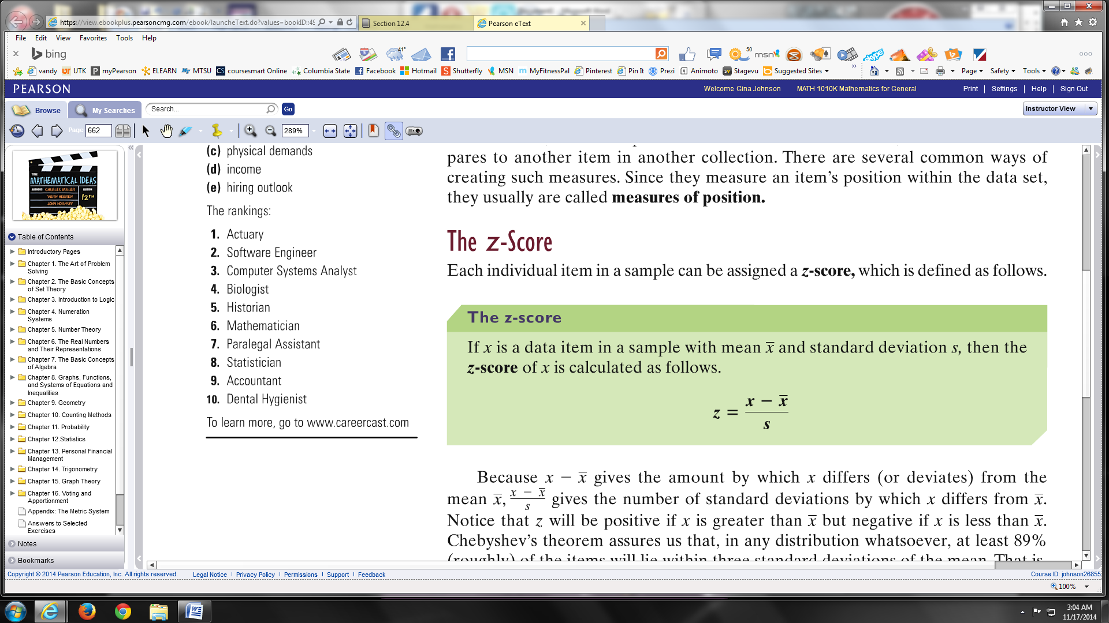

**EXAMPLE:** Ann made an 86 on her history midterm and Kay made a 78 on hers. Which student is doing better (ranked higher) in their history classes?

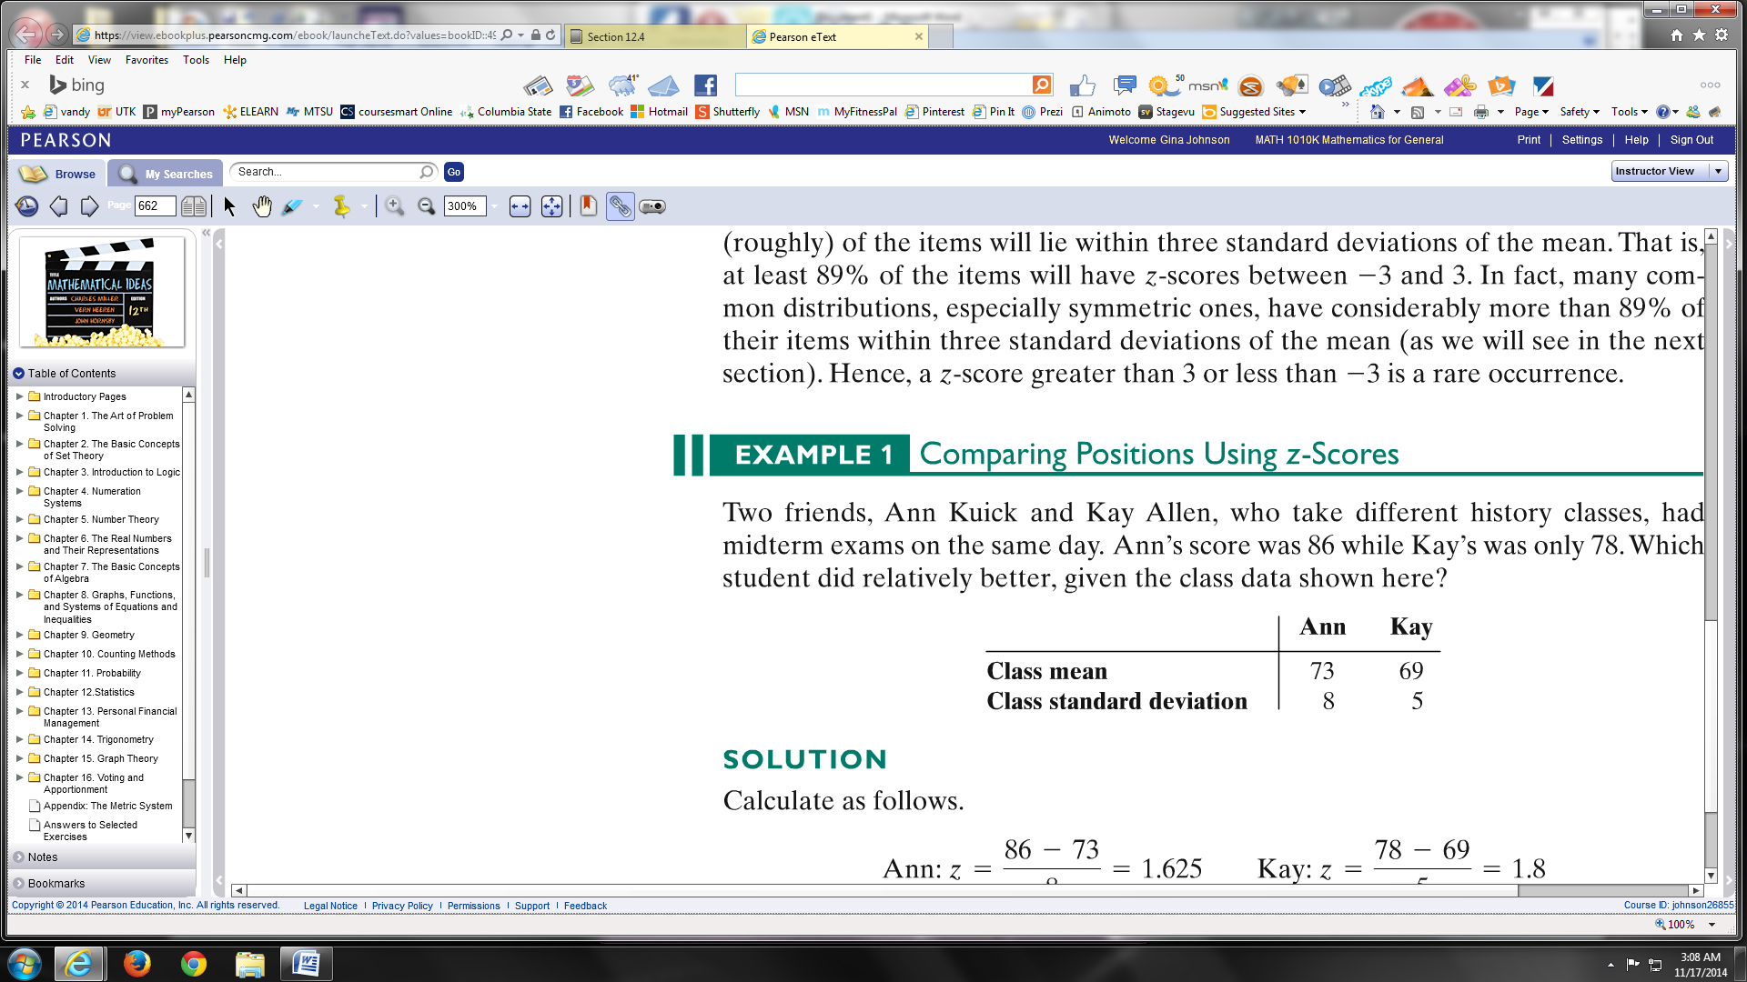

**EXAMPLE:** Using the chart of populations of some countries, compute the z-score for Japan’s population.

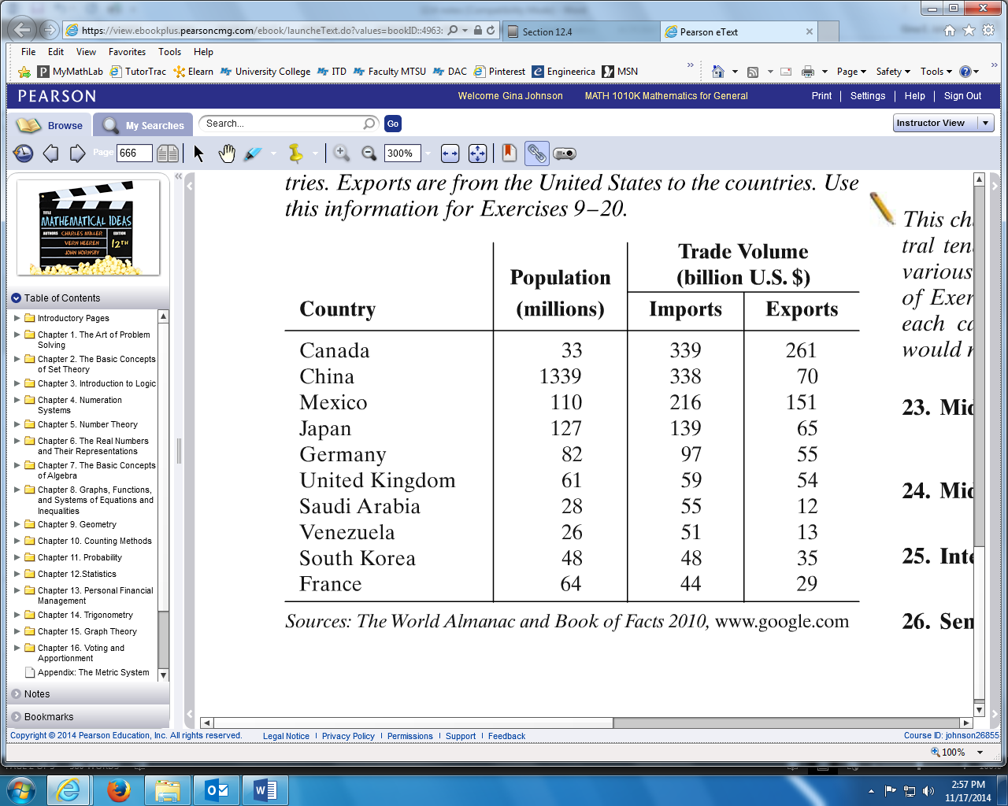

First, use calculator to computer mean

and standard deviation.

Second, find z-score using formula.

**II. Percentiles**

If you have ever taken a standardized test, such as t-cap, ACT, SAT, MCAT, etc, then your raw score is converted to a percentile. If you scored at the 83rd percentile on the SAT, then that means you did better than 83% of the people who took the test. This does **not** mean you scored an 83% on your test.

Remember a percent is always ___________________.

**Percentile = percent times the number of data items = the position of the item**

*Percentile is rounded up to the next number to begin the percentile*

To locate the position of the item, all items must be ranked from least to greatest

**EXAMPLE:** Below is a list of the number of customers served by a restaurant for 40 days. Find the 35th percentile and the 86th percentile.

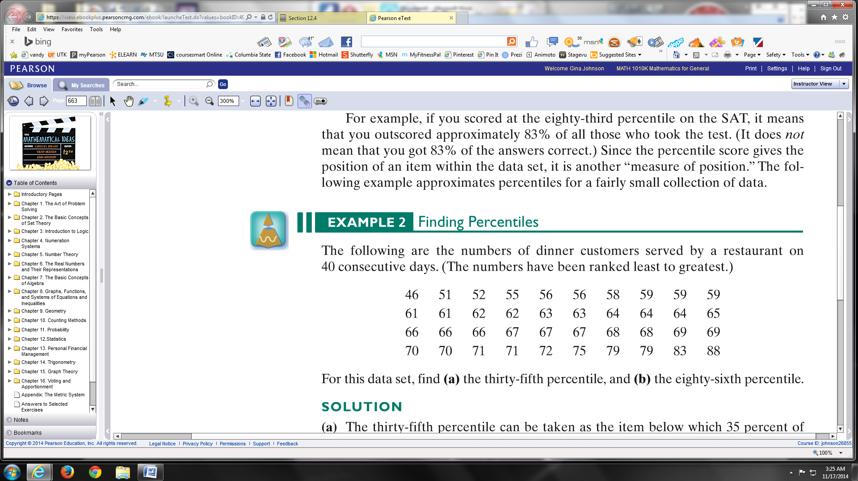

35th percentile: 86th percentile:

**III. Quartiles**

Quartiles of a data set are _____________________ that divide the data set into

four “equal-sized” parts.

Quartiles use the _______________________ which means the data set must be in

numerical order.

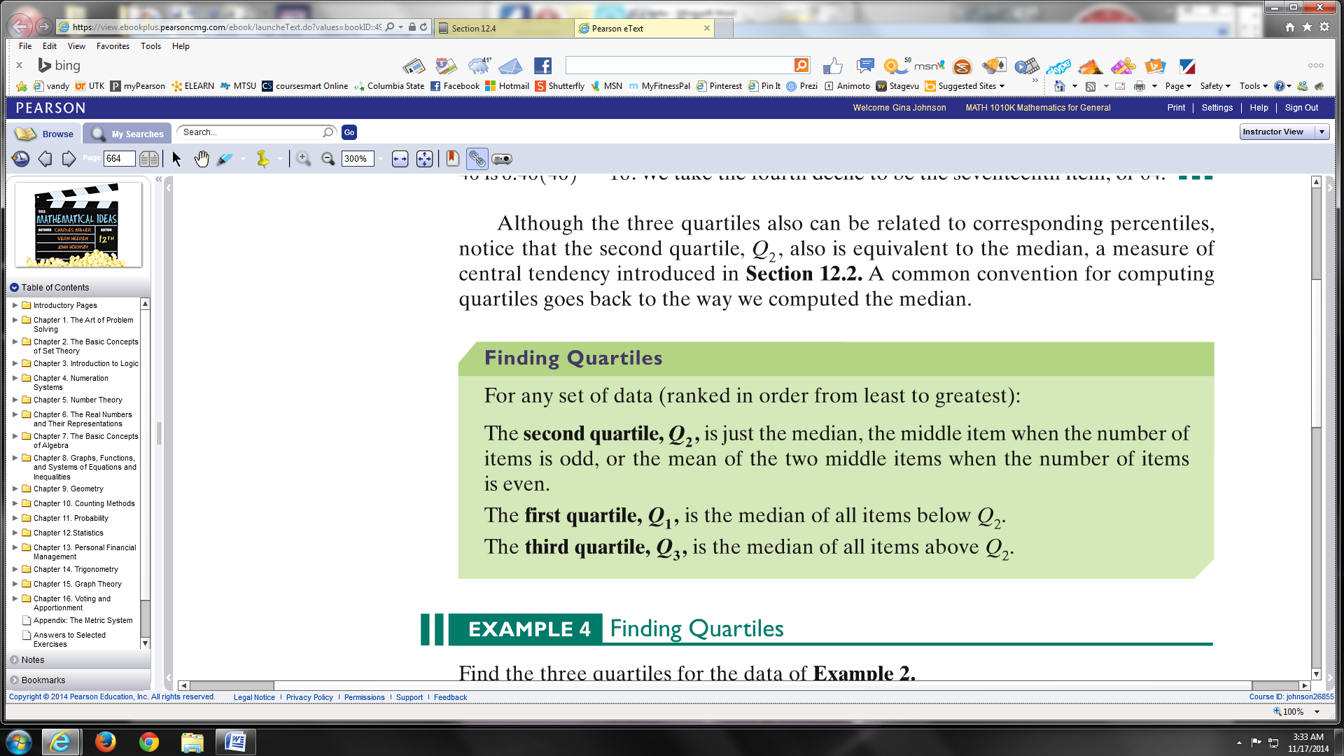

**EXAMPLE:** Below is a list of the number of customers served by a restaurant for 40 days. Find the three quartiles for the data set (median means middle number).



Second quartile, ***Q2*** :

First quartile, ***Q1*** :

Third quartile, ***Q3*** :